**Application Logs**

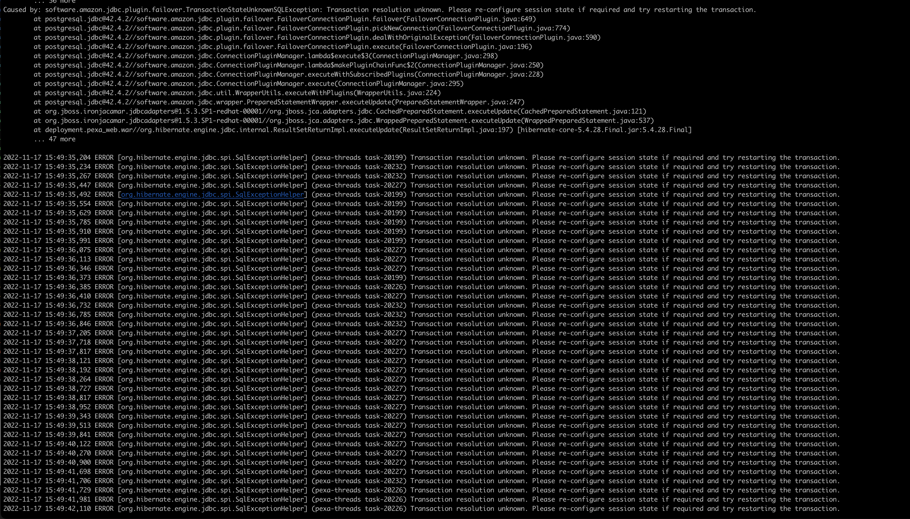

**JBoss EAP Standalone Data Source Config**

<subsystem xmlns="urn:jboss:domain:datasources:6.0">

<datasources>

<datasource jndi-name="java:jboss/datasources/pexa" pool-name="pexa" statistics-enabled="true">

<connection-url>jdbc:aws-wrapper:postgresql://cluster-caq6bzfzzulv.ap-southeast-2.rds.amazonaws.com:5432/prf02</connection-url>

<connection-property name="ApplicationName">

prf02-CoreApp-pexa-writer

</connection-property>

<connection-property name="targetServerType">primary</connection-property>

<connection-property name="wrapperPlugins">failover</connection-property>

<security>

<user-name>pexa_prf02</user-name>

<credential-reference store="pexa" alias="pexa"/>

</security>

<driver>PostgresqlJDBCDriver</driver>

<pool>

<min-pool-size>15</min-pool-size>

<max-pool-size>40</max-pool-size>

<prefill>true</prefill>

<use-strict-min>true</use-strict-min>

<flush-strategy>AllIdleConnections</flush-strategy>

</pool>

<validation>

<validate-on-match>false</validate-on-match>

<background-validation>true</background-validation>

<background-validation-millis>60000</background-validation-millis>

<valid-connection-checker class-name="org.jboss.jca.adapters.jdbc.extensions.postgres.PostgreSQLValidConnectionChecker"/>

<exception-sorter class-name="org.jboss.jca.adapters.jdbc.extensions.postgres.PostgreSQLExceptionSorter"/>

</validation>

<timeout>

<blocking-timeout-millis>30000</blocking-timeout-millis>

<idle-timeout-minutes>2</idle-timeout-minutes>

</timeout>

<statement>

<prepared-statement-cache-size>700</prepared-statement-cache-size>

<share-prepared-statements>true</share-prepared-statements>

</statement>

</datasource>

<datasource jndi-name="java:jboss/datasources/pexa_replica" pool-name="pexa_replica" statistics-enabled="true">

<connection-url>jdbc:aws-wrapper:postgresql://cluster-ro-caq6bzfzzulv.ap-southeast-2.rds.amazonaws.com:5432/prf02</connection-url>

<connection-property name="ApplicationName">

prf02-CoreApp-pexa-replica-reader

</connection-property>

<connection-property name="targetServerType">secondary</connection-property>

<connection-property name="wrapperPlugins">failover</connection-property>

<connection-property name="readOnly">true</connection-property>

<security>

<user-name>pexa_prf02</user-name>

<credential-reference store="pexa" alias="pexa"/>

</security>

<driver>PostgresqlJDBCDriver</driver>

<pool>

<min-pool-size>15</min-pool-size>

<max-pool-size>40</max-pool-size>

<prefill>true</prefill>

<use-strict-min>true</use-strict-min>

<flush-strategy>AllIdleConnections</flush-strategy>

</pool>

<validation>

<validate-on-match>false</validate-on-match>

<background-validation>true</background-validation>

<background-validation-millis>60000</background-validation-millis>

<valid-connection-checker class-name="org.jboss.jca.adapters.jdbc.extensions.postgres.PostgreSQLValidConnectionChecker"/>

<exception-sorter class-name="org.jboss.jca.adapters.jdbc.extensions.postgres.PostgreSQLExceptionSorter"/>

</validation>

<timeout>

<blocking-timeout-millis>30000</blocking-timeout-millis>

<idle-timeout-minutes>2</idle-timeout-minutes>

</timeout>

<statement>

<prepared-statement-cache-size>700</prepared-statement-cache-size>

<share-prepared-statements>true</share-prepared-statements>

</statement>

</datasource>

<datasource jndi-name="java:jboss/datasources/pexaBatch" pool-name="pexaBatch" statistics-enabled="true">

<connection-url>jdbc:aws-wrapper:postgresql://cluster-caq6bzfzzulv.ap-southeast-2.rds.amazonaws.com:5432/prf02</connection-url>

<connection-property name="ApplicationName">

prf02-CoreApp-pexa-batch-writer

</connection-property>

<connection-property name="targetServerType">primary</connection-property>

<connection-property name="wrapperPlugins">failover</connection-property>

<security>

<user-name>pexa_prf02</user-name>

<credential-reference store="pexa" alias="pexa"/>

</security>

<driver>PostgresqlJDBCDriver</driver>

<pool>

<min-pool-size>1</min-pool-size>

<max-pool-size>80</max-pool-size>

<prefill>false</prefill>

<use-strict-min>false</use-strict-min>

</pool>

<validation>

<validate-on-match>false</validate-on-match>

<background-validation>true</background-validation>

<background-validation-millis>60000</background-validation-millis>

<valid-connection-checker class-name="org.jboss.jca.adapters.jdbc.extensions.postgres.PostgreSQLValidConnectionChecker"/>

<exception-sorter class-name="org.jboss.jca.adapters.jdbc.extensions.postgres.PostgreSQLExceptionSorter"/>

</validation>

<timeout>

<idle-timeout-minutes>2</idle-timeout-minutes>

<blocking-timeout-millis>30000</blocking-timeout-millis>

</timeout>

<statement>

<share-prepared-statements>false</share-prepared-statements>

</statement>

</datasource>

<datasource jndi-name="java:jboss/datasources/pexaNonManaged" pool-name="pexaNonManaged" statistics-enabled="true">

<connection-url>jdbc:aws-wrapper:postgresql://cluster-caq6bzfzzulv.ap-southeast-2.rds.amazonaws.com:5432/prf02</connection-url>

<connection-property name="ApplicationName">

prf02-CoreApp-pexa-quartz-writer

</connection-property>

<connection-property name="targetServerType">primary</connection-property>

<connection-property name="wrapperPlugins">failover</connection-property>

<security>

<user-name>pexa_prf02</user-name>

<credential-reference store="pexa" alias="pexa"/>

</security>

<driver>PostgresqlJDBCDriver</driver>

<pool>

<min-pool-size>1</min-pool-size>

<max-pool-size>80</max-pool-size>

<prefill>false</prefill>

<use-strict-min>false</use-strict-min>

</pool>

<validation>

<validate-on-match>false</validate-on-match>

<background-validation>true</background-validation>

<background-validation-millis>600000</background-validation-millis>

<valid-connection-checker class-name="org.jboss.jca.adapters.jdbc.extensions.postgres.PostgreSQLValidConnectionChecker"/>

<exception-sorter class-name="org.jboss.jca.adapters.jdbc.extensions.postgres.PostgreSQLExceptionSorter"/>

</validation>

<timeout>

<blocking-timeout-millis>30000</blocking-timeout-millis>

<idle-timeout-minutes>2</idle-timeout-minutes>

</timeout>

<statement>

<share-prepared-statements>false</share-prepared-statements>

</statement>

</datasource>

<datasource jndi-name="java:jboss/datasources/cas" pool-name="cas" statistics-enabled="true">

<connection-url>jdbc:aws-wrapper:postgresql://cluster-caq6bzfzzulv.ap-southeast-2.rds.amazonaws.com:5432/prf02</connection-url>

<connection-property name="ApplicationName">

prf02-CoreApp-cas-writer

</connection-property>

<connection-property name="targetServerType">primary</connection-property>

<connection-property name="wrapperPlugins">failover</connection-property>

<security>

<user-name>cas_prf02</user-name>

<credential-reference store="pexa" alias="pexa_cas"/>

</security>

<driver>PostgresqlJDBCDriver</driver>

<pool>

<min-pool-size>1</min-pool-size>

<max-pool-size>80</max-pool-size>

<prefill>false</prefill>

<use-strict-min>false</use-strict-min>

</pool>

<validation>

<validate-on-match>false</validate-on-match>

<background-validation>true</background-validation>

<background-validation-millis>60000</background-validation-millis>

<valid-connection-checker class-name="org.jboss.jca.adapters.jdbc.extensions.postgres.PostgreSQLValidConnectionChecker"/>

<exception-sorter class-name="org.jboss.jca.adapters.jdbc.extensions.postgres.PostgreSQLExceptionSorter"/>

</validation>

<timeout>

<blocking-timeout-millis>30000</blocking-timeout-millis>

<idle-timeout-minutes>2</idle-timeout-minutes>

</timeout>

<statement>

<share-prepared-statements>false</share-prepared-statements>

</statement>

</datasource>

<drivers>

<driver name="PostgresqlJDBCDriver" module="postgresql.jdbc">

<driver-class>software.amazon.jdbc.Driver</driver-class>

</driver>

</drivers>

</datasources>

**Failover Test Results**

Test 1 trigger 3:14 - **Failure**

No recovery for over 30mins. Previous testing saw instability for approximately 15 - 20mins before recovery was possible, however given the high and consistent volume of errors, recovery appears unlikely.  
Load generator 3 was stopped to try regaining stability, but even after 5 minutes no appreciable change was observed and errors remained.

This driver requires further testing and cannot be "dropped in" as a replacement. No further testing will be conducted at this stage. Backing out this deployment and proceeding with previous driver.

